NATIONAL UNIVERSITY OF MODERN LANGUAGES
MIRPUR AZAD KASHMIR CAMPUS


FACULTY OF ENGINEERING AND COMPUTER SCIENCE
DEPARTMENT OF SOFTWARE ENGINEERING
COURSE ASSIGNMENT DETAILS
FULL NAME | Abdul Samad, Ibrar
UNIVERSITY REGISTRATION NO | Numl f23 89849,
COURSE CODE | SDA
COURSE TITLE | SOFTWRE DESGIN
ASSIGNMENT NO | 02
CATEGORY | (Theory/Lab)
SEMESTER
SESSION | FALL
SUBMISSION DATE
INSTRUCTOR NAME | Sir Asad Nawaz

MARKS DETAILS
TOTAL MARKS | OBTAINED MARKS | FACULTY SIGNATURE

REMARKS (Optional)
REMARKS DETAILS

Activity Diagram
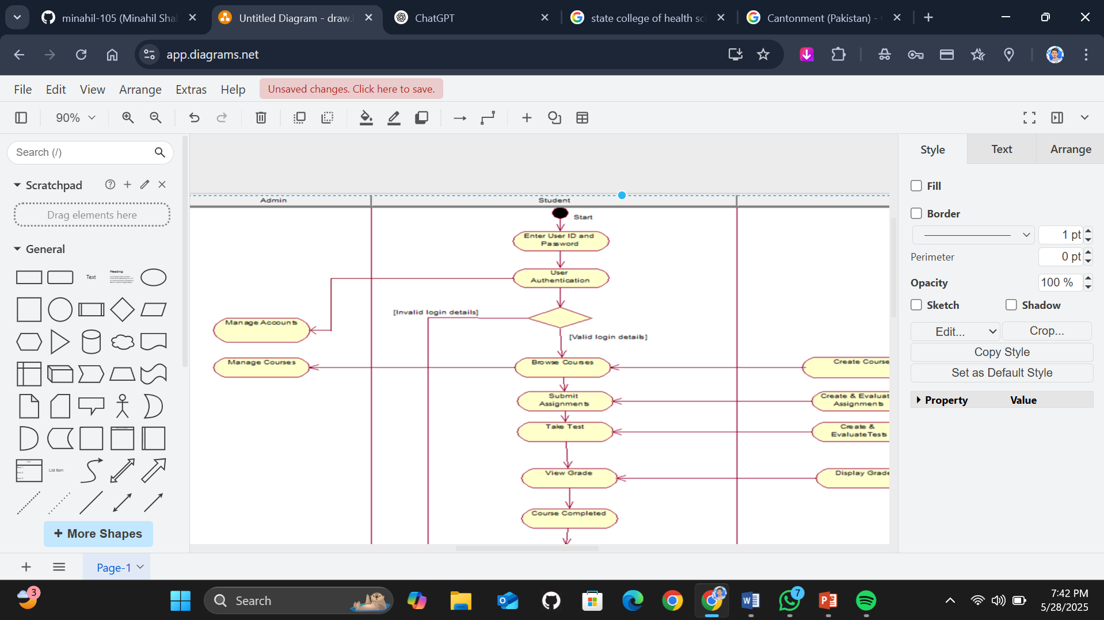
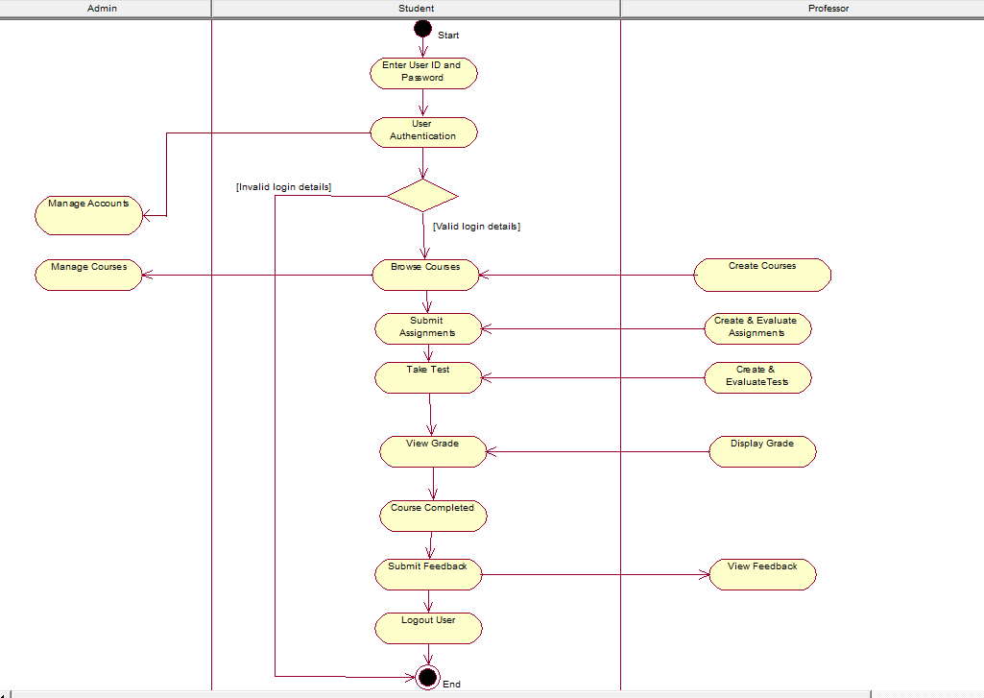

Domain Model
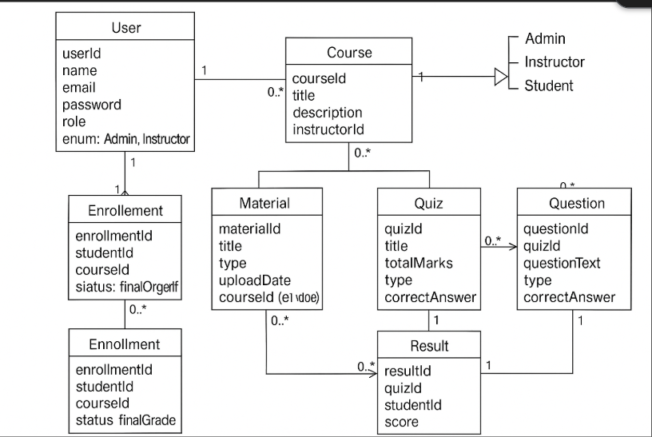
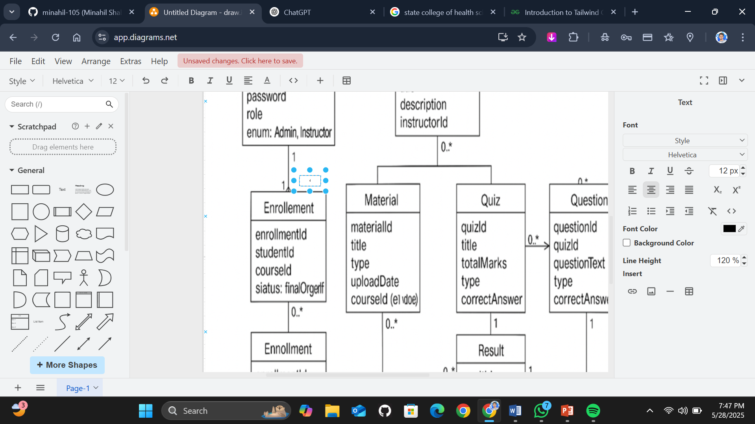

The UML sequence diagram illustrates the process of a student enrolling in a course and accessing its materials on an online learning platform. The interaction begins with the Student sending a viewCourses() request to the CourseCatalog to explore available courses. After selecting a desired course, the student invokes the enroll(course) method on the Course object. The course, in turn, communicates with the EnrollmentManager by calling confirmEnrollment() to validate and finalize the enrollment process.

Class Diagram.
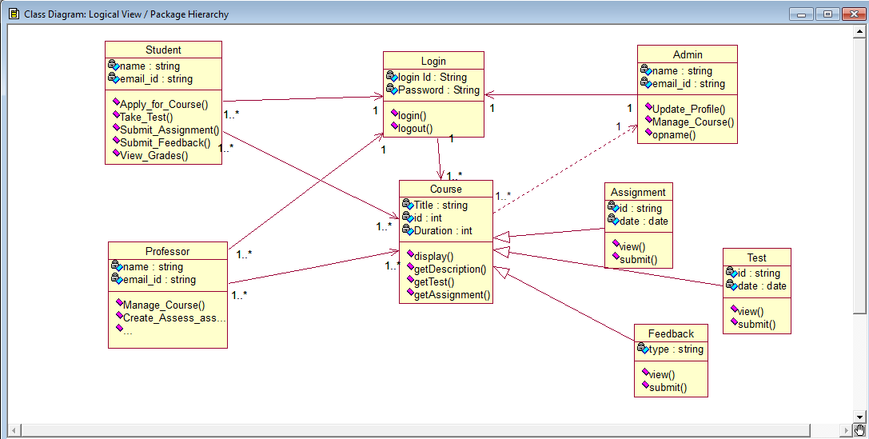
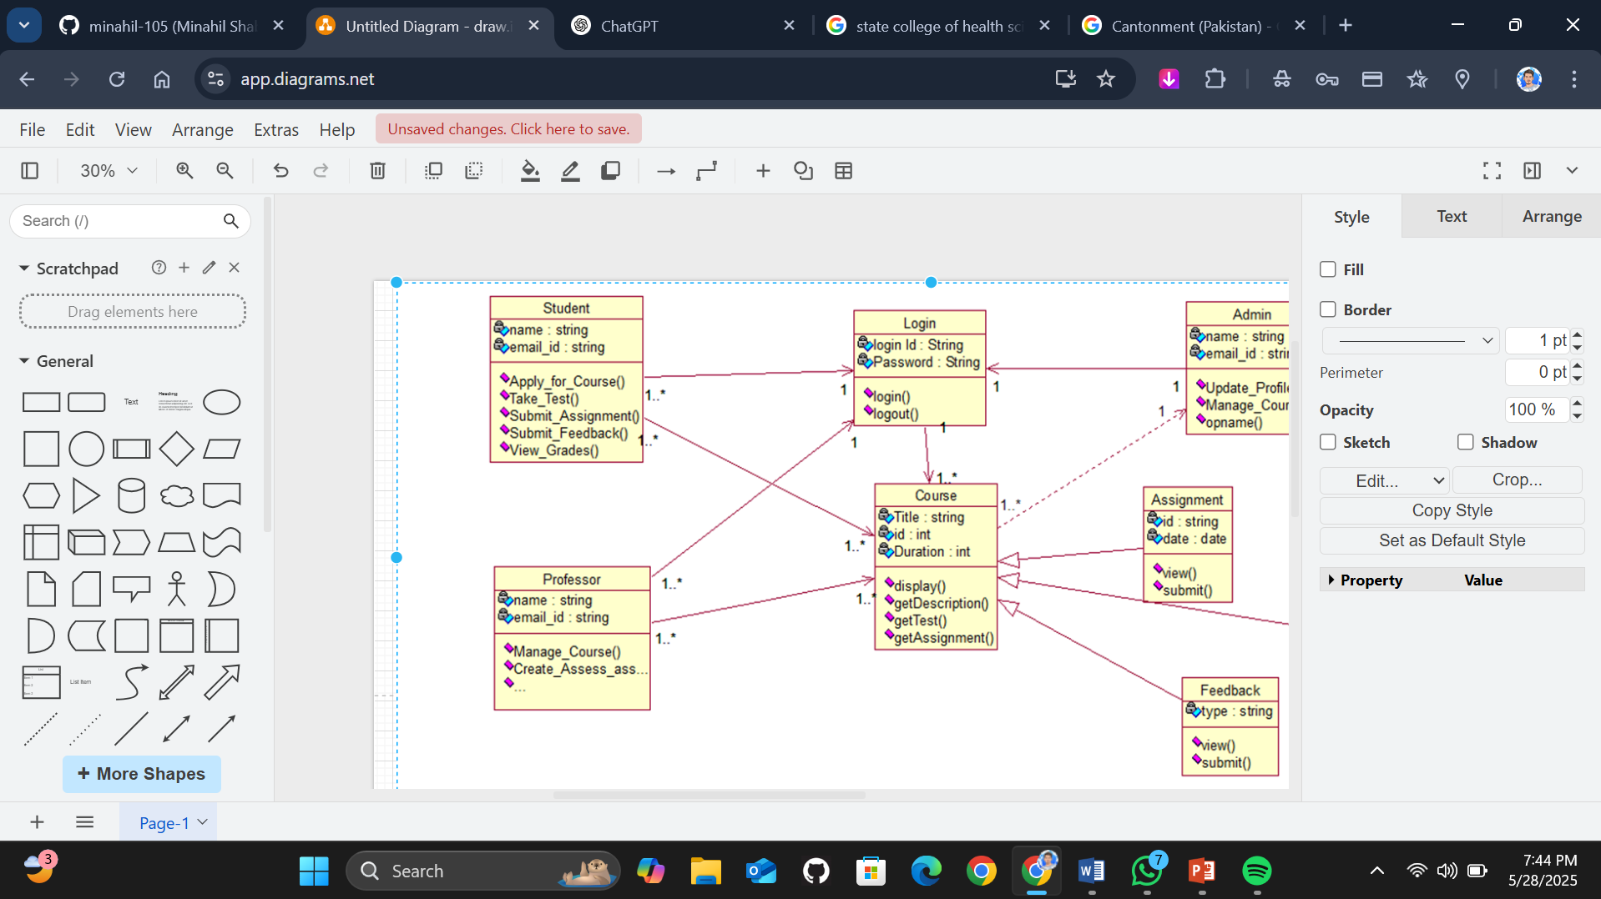

Use Case Diagram

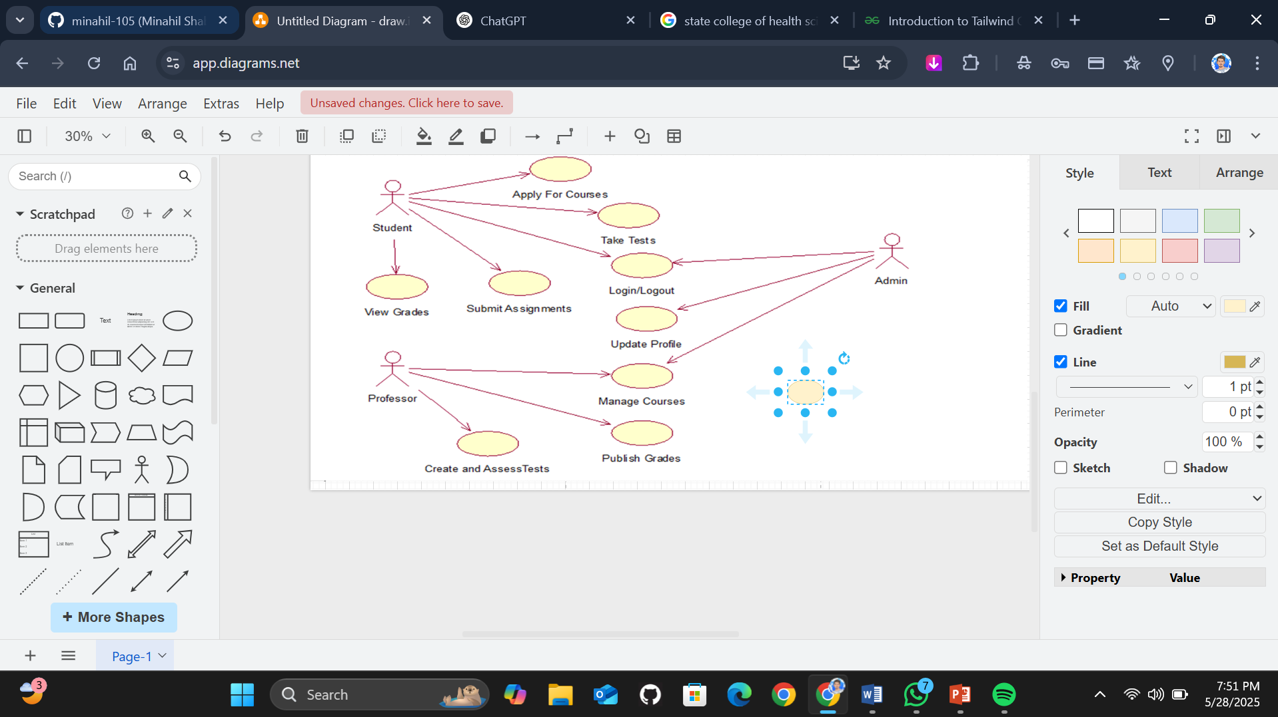

Sequence Diagram ~ Professor

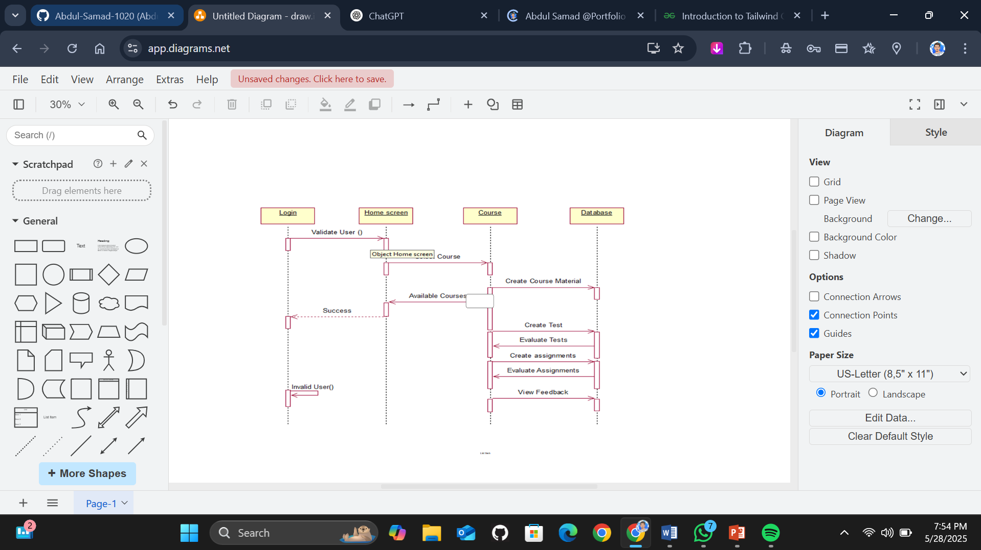
~Student
